**9C_B_04A Purchase Order**

**Retest Date: 04-12-2023**

**Browser: Microsoft Edge**

**In UI:**

**In 50 Live Server the UI is OK, both UI & PDF, Please follow 50 Server Report before start fixing**

1. Remove Store Name, Indent Number & Indent Date
2. Add Purchase Order No, Date, Supplier Name, Rate, Amount and Remarks
3. Qty is not showing

**In PDF:**

1. PO No is not showing
2. Mobile No. is not showing
3. Add Master Group name after Mobile No
4. PO Date format is wrong, it should be: dd-mm-yyyy
5. Delivery Point, Delivery Date and Pay Term is missing, add those field as Right Aligned
6. Amount In Words is missing
7. Submitted by is not showing
8. 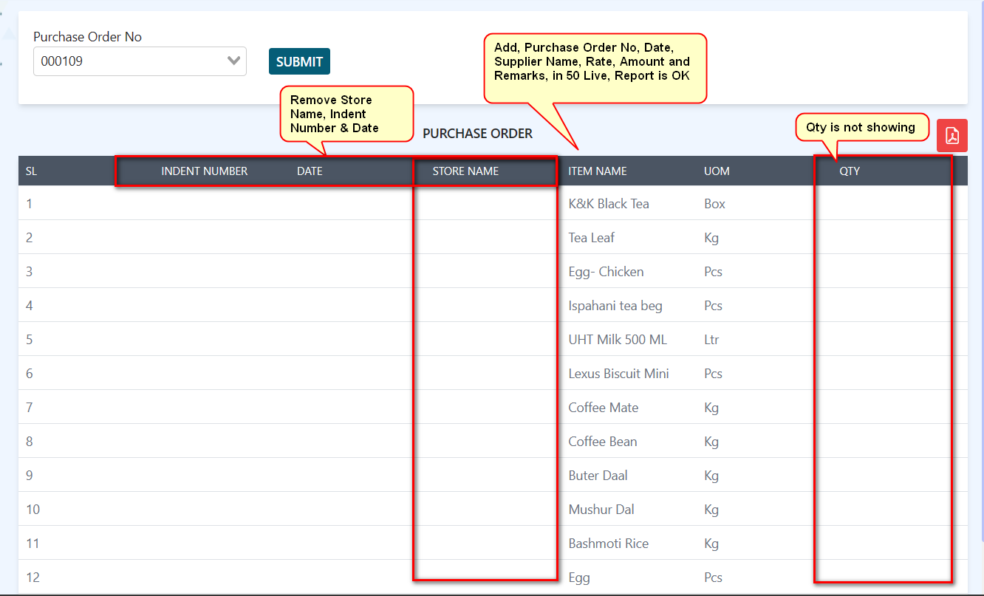
9. 